Stereology macro new version instructions 07102019

1. Open FIJI
2. Plugins->Macros->edit
   1. Select Hutchens Lab Common Folder/Stereology plugin/UnbiasedSampling_HutchensLab_07102019j
3. Go back to FIJI toolbar window.
4. File->open a CZI file and select one of the ~6000-8000 pixel kidney sections (for example, #2).
5. Go back to the macro edit window, click “RUN”
6. Create a new folder with the mouse ID, section number, and stain (KIM1) in the name of the folder, like below:
7. 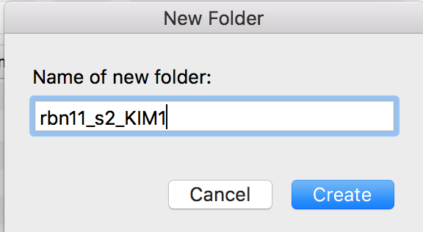
8. In the setup window, just click “OK” at the bottom. The default values are setup for the KIM 1 pictures:
9. 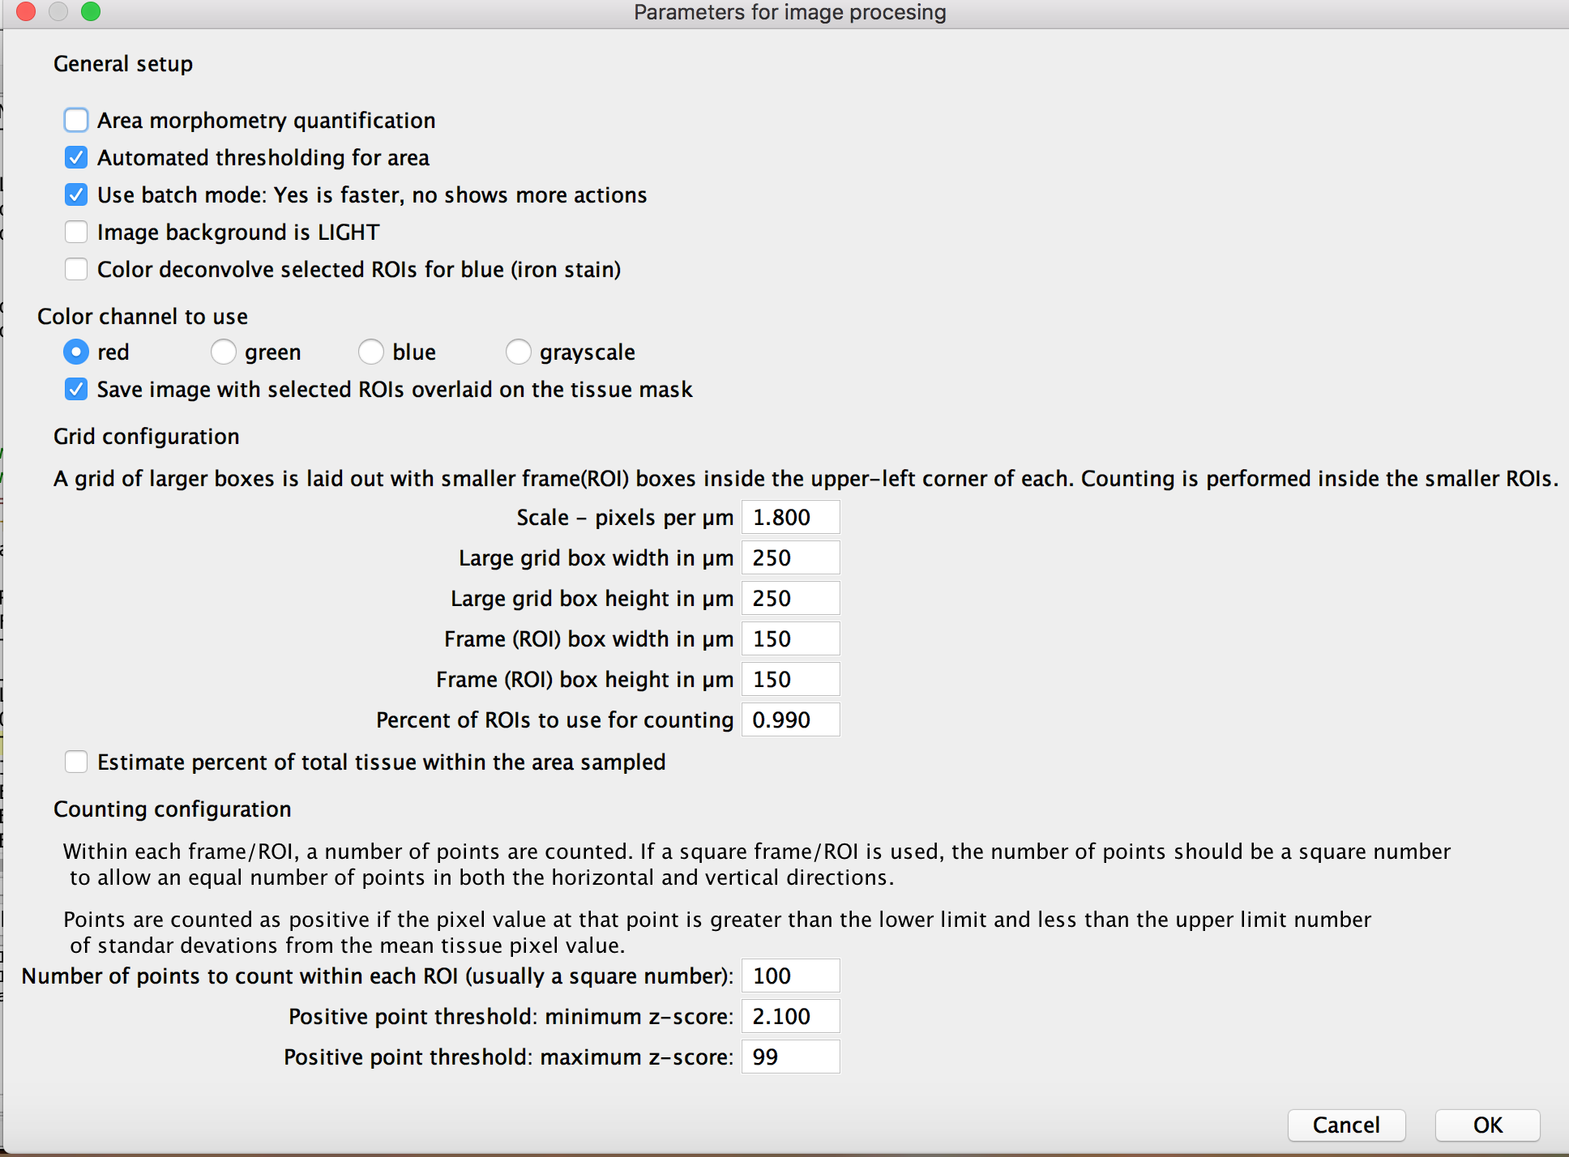
10. Let the macro run. You don’t have to do anything anymore, it’s totally automatic. At the end you get the “all done” message:
11. 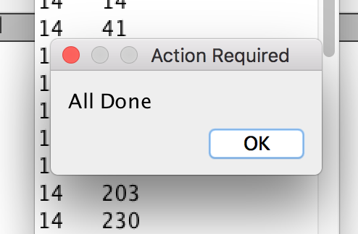
12. Next, look in the folder you made:
13. 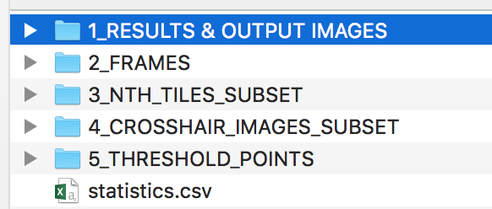
14. The file “statistics.csv” contains the most important stuff – it is a one line excel file. You copy that one line into an excel spreadsheet that you put all the data from all the mice into. So there are 40 KIM-1 stained slides, each with 4 sections – you will end up with an excel file with 160 lines for all the mice.
15. You should also look at some other files:
    1. In 1_RESULTS & OUTPUT IMAGES:
       1. Look at “Final_stats.txt” – this is all the data about the image in one file
       2. Look at Image_enhancement_montage.png – this is what the image looked like before and after the image enhancement in the macro. It’s mostly just FYI
    2. In 5_THRESHOLD_POINTS: just look through the images (it’s best to use windows explorer/the finder and the preview view just so you can see them quickly). Just scan. Positive points (circles with a cross) should only fall on KIM-1 positive tubules for the most part.

That’s it!